Access Control V2.2 User Manual

Access Control V2.2 User Manual 1
1. Operating Environment 3
2. CFAccess Operation Guide 4
2.1）Login screen 4
2.2）Main interface - Home page - Language settings 5
2.3）Real-time monitoring 6
2.4）Gate Device 6
2.4.1) Parameter configuration 11
A) Frequency 11
B) Antenna & Power 12
C) Reading 13
D) GPIO 14
E) Advanced Settings 15
F) Communication 16
G) Gate 17
2.5）Change Password 19
2.6）Database Setting 20
2.7）Upload Template 22
2.8）Server Configuration 23

Operating Environment
This software supports systems: Windows 2000, Windows XP, Windows 7, Windows 8, Windows 10, Windows 2003 and higher.
Need .NET 6 Runtime\.NET 6 SDK

CFAccess Operation Guide

2.1）Login screen
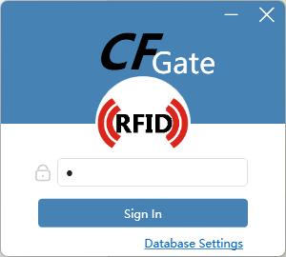
- This interface is used to log in to the system (the default password is 1)
- Click Database Settings to set the database type for this operation.
- Currently supported databases are SQLite (standalone) and SQL Server (LAN/Internet)
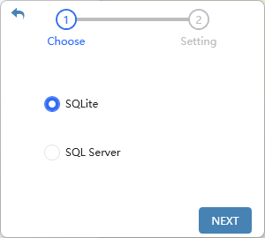

2.2）Main interface - Home page - Language settings
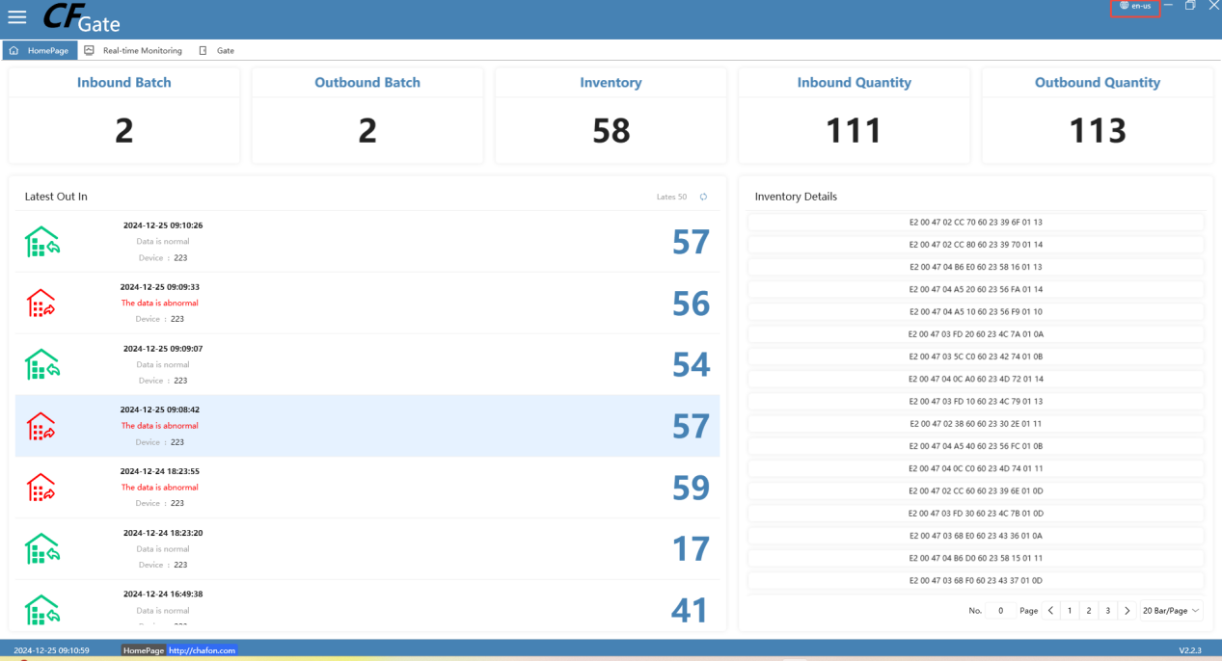
- After entering the password to log in, we will enter the home page. We can set the language in the upper right corner of the interface
- Click the icon next to the CFAccess logo, and we will open the menu bar on the left, where we can select the page you need to enter
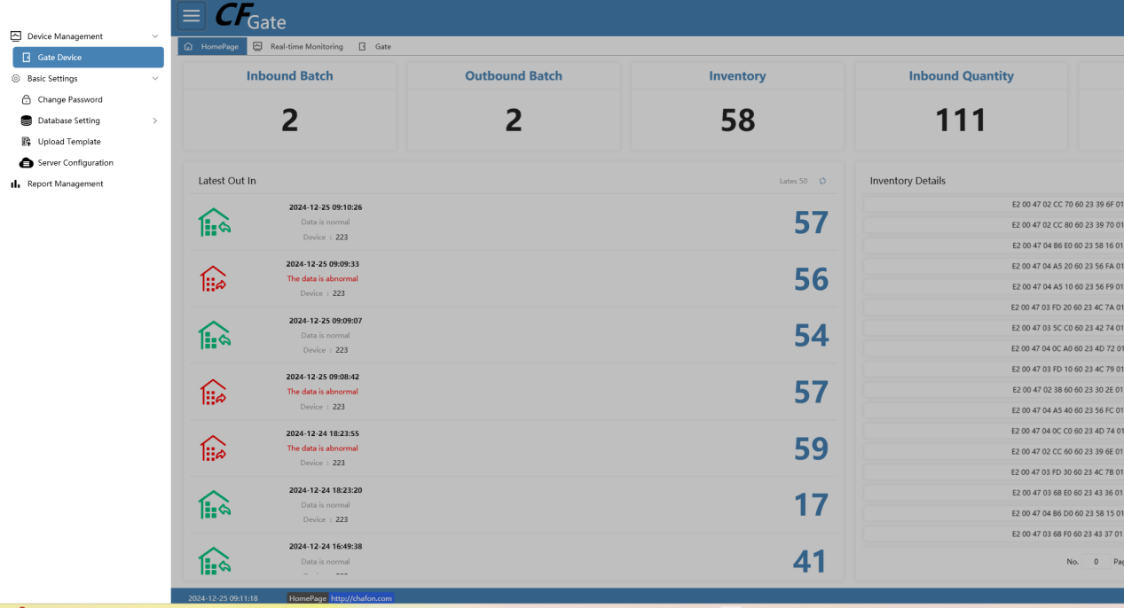

2.3）Real-time monitoring
In the real-time monitoring interface, you can select the corresponding device to view the real-time monitored card reading data, which can be transferred to an Excel table.
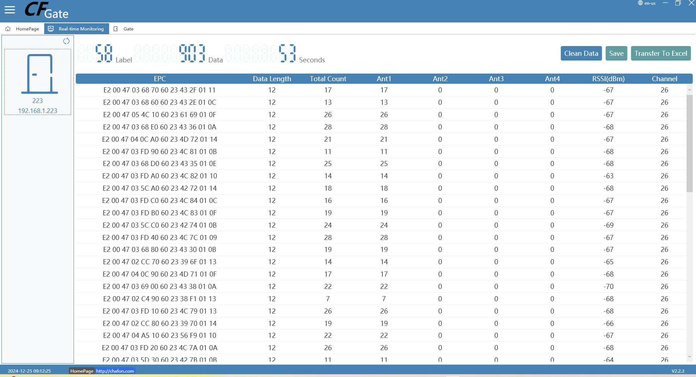

2.4）Gate Device
The devices are divided into access control devices and door channel devices. Select the corresponding interface to add according to the device you bought.
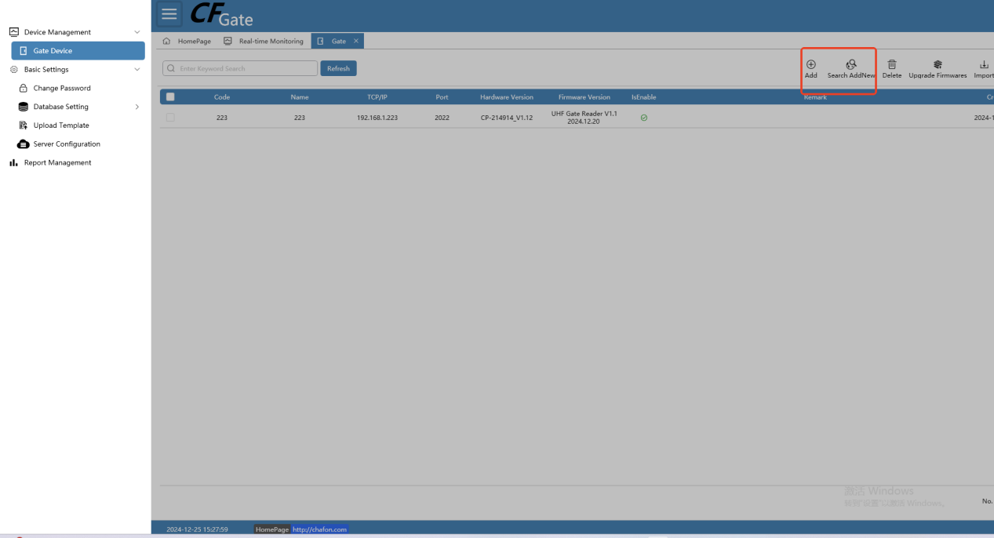
- Double-click the [Device] option to open the interface above. We can add new devices, synchronize whitelist data, update firmware, and import devices in batches on this interface.
- Click the [Add] button to manually add a device. There are two modes for adding a device, namely [Wizard Mode] and [Professional Mode]. We can choose the one that suits us.
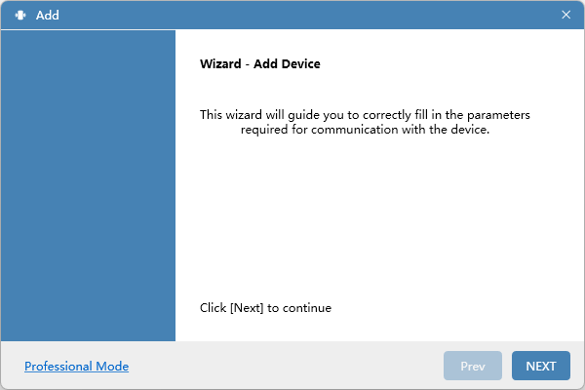
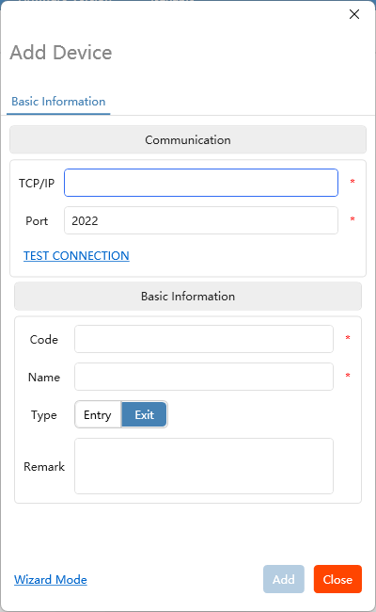
- Click the [Search and Add] button to search for devices in the LAN. We can add the searched devices in batches or add them individually from the right-click menu.
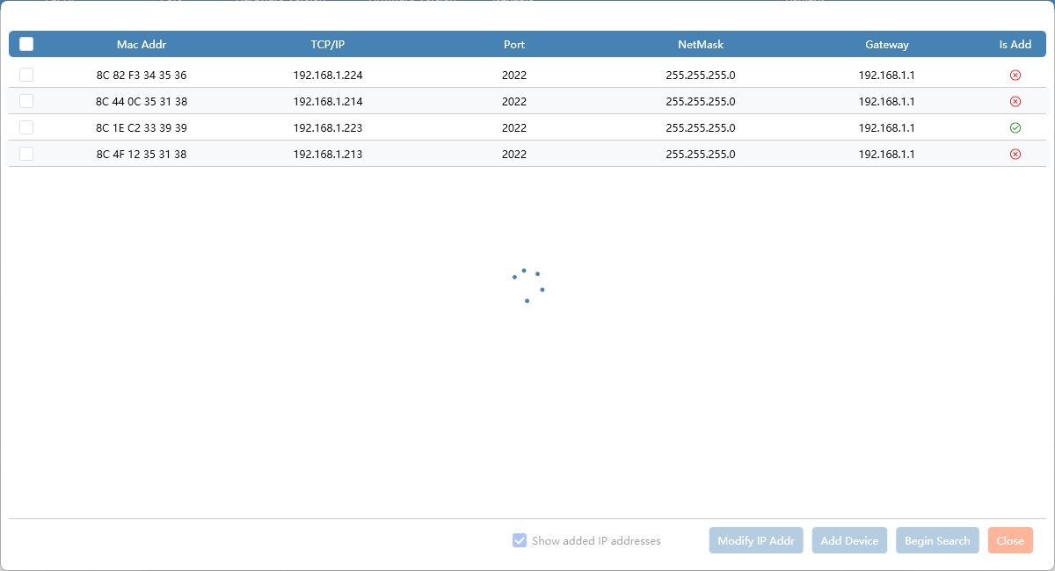
- By checking the list, we can also process the device accordingly through buttons such as [Batch Synchronize Data], [Batch Upgrade Firmware], [Delete], etc.
- Right click on the device we need to operate, and we can perform some corresponding operations on the device separately.
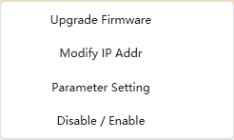
- Through the list, we can also perform operations such as [Edit], [Assign Permission Group], and [Delete] on a single device.
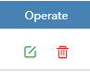
- Through [Import], [Import Template], [Export], we can also back up data, or quickly add new devices in batches, etc.
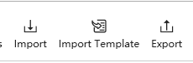
- Click [Operation Record] to view the recent operations on the device.
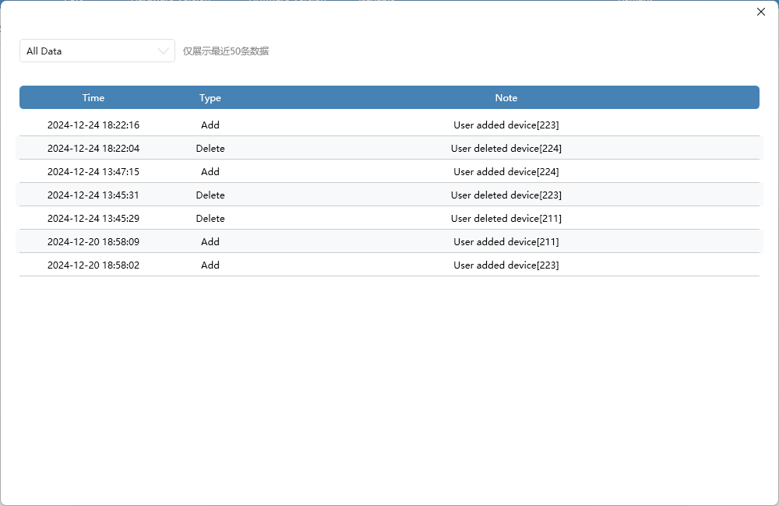

2.4.1) Parameter configuration

A) Frequency
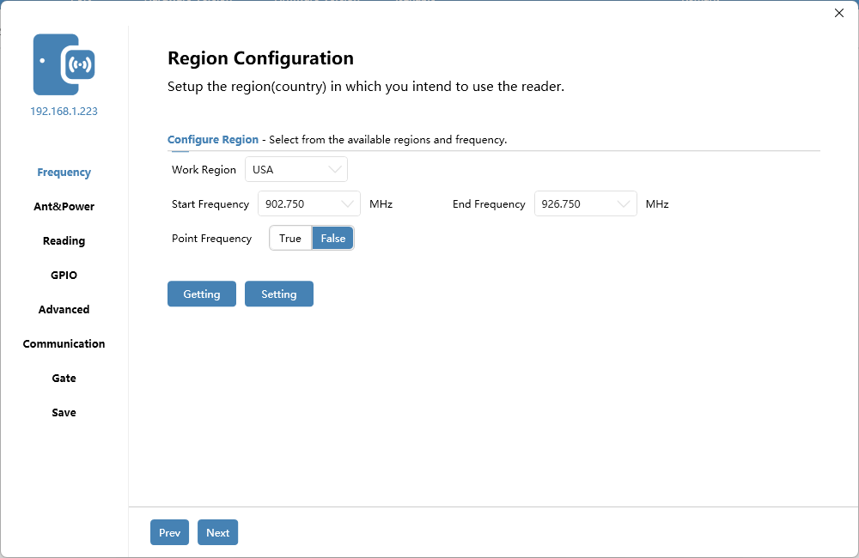
We can configure parameters such as working area, frequency, etc. here.

Antenna & Power
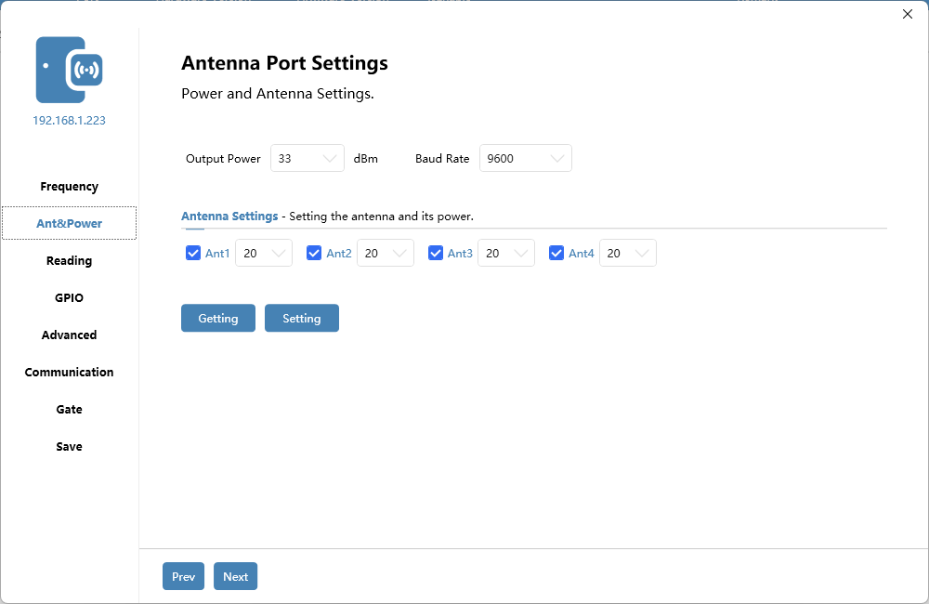
We can configure antenna, power and other parameters here.

Reading
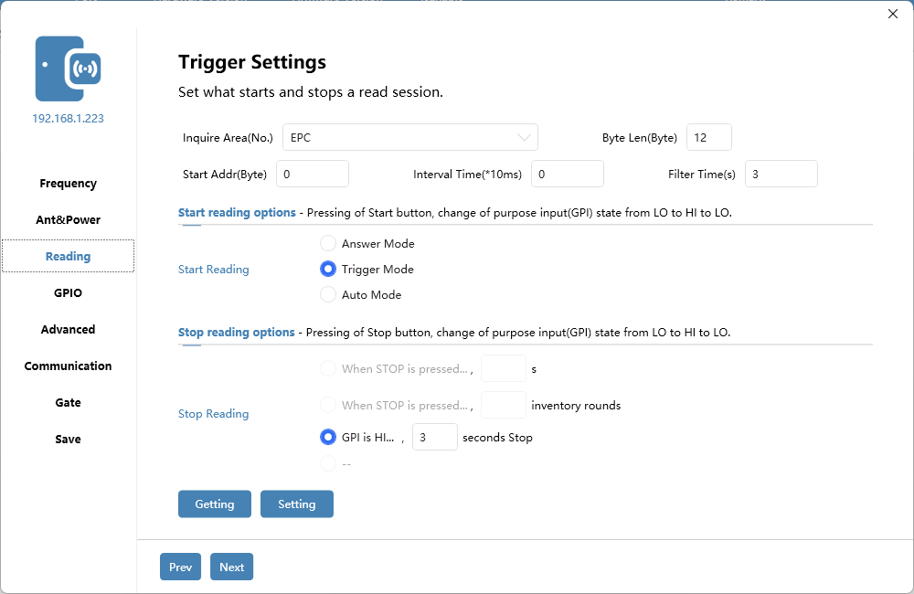
We can configure the area, working mode, and query related parameters here.

GPIO
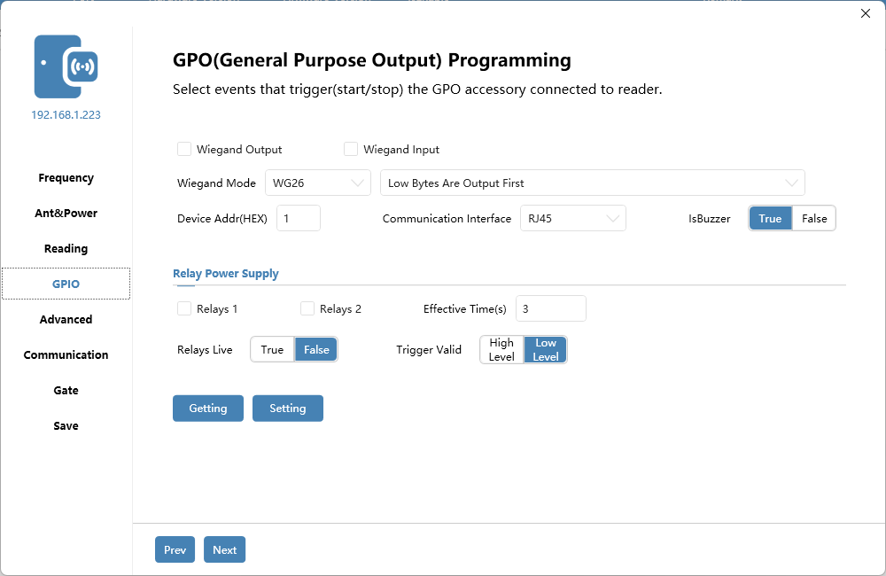
We can configure GPIO and relay related parameters here.
When we need to connect to the Internet, please change the communication interface to RJ45.

Advanced Settings
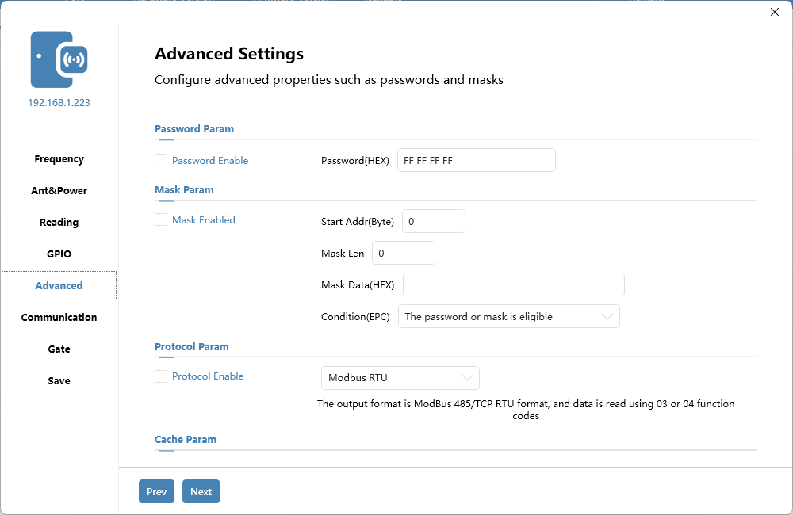
We can configure the password, mask, protocol enable and other related parameters here.

Communication
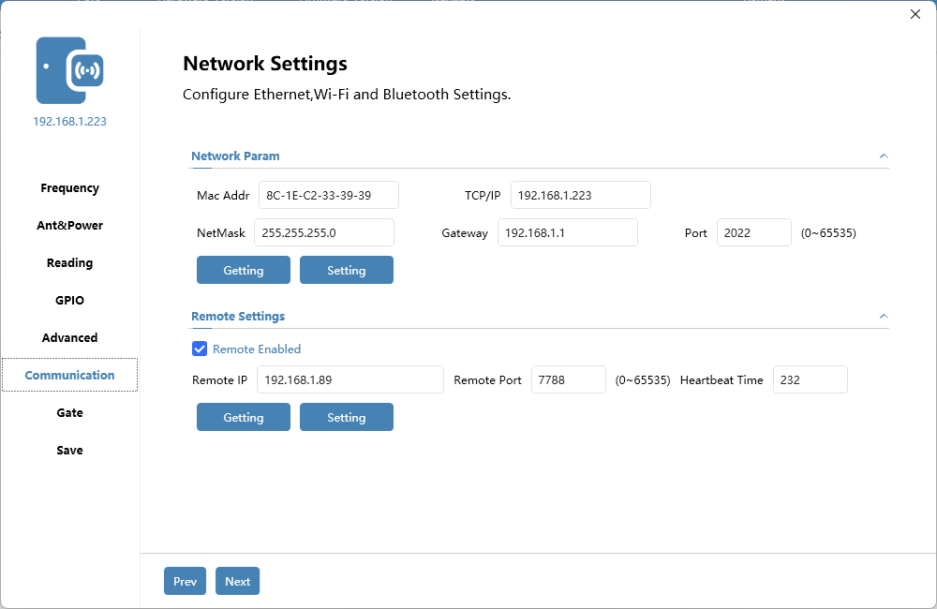
We can configure network, remote and other related parameters here.
When we need to connect to the Internet, please check the remote enable and change the IP address to the server's IP address, and set the port number to 7788.

Gate
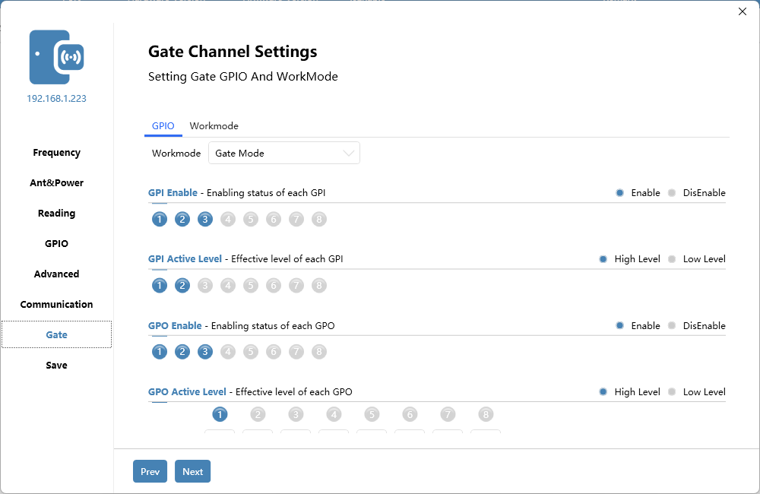
We can configure the device's working mode (general mode, gate channel mode) here.
GPIO can be configured through this interface.

When the device works in gate channel mode, we can also configure the gate channel working mode (inventory mode, EAS mode).
Inventory：
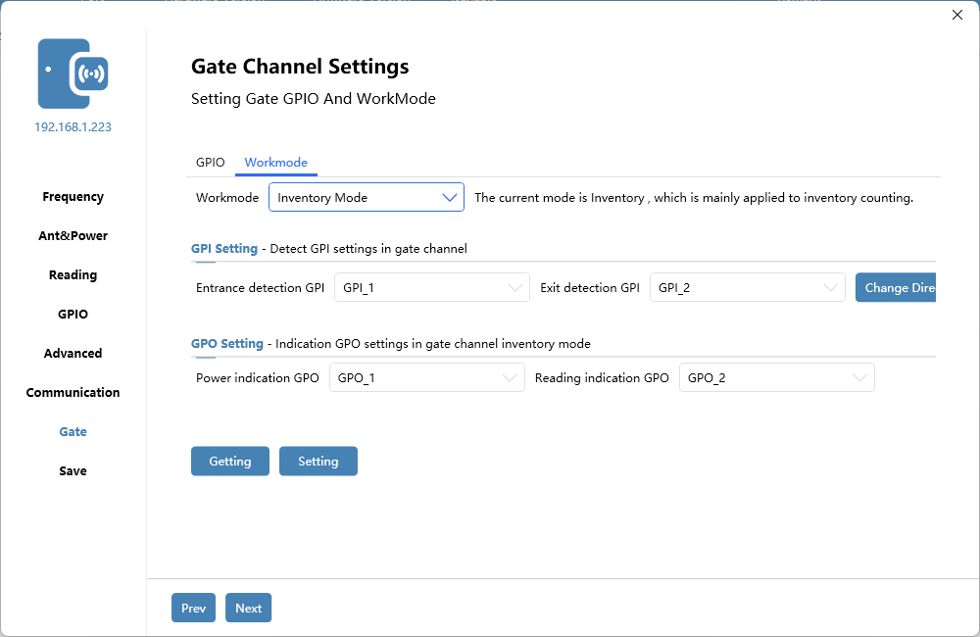
EAS Mode：
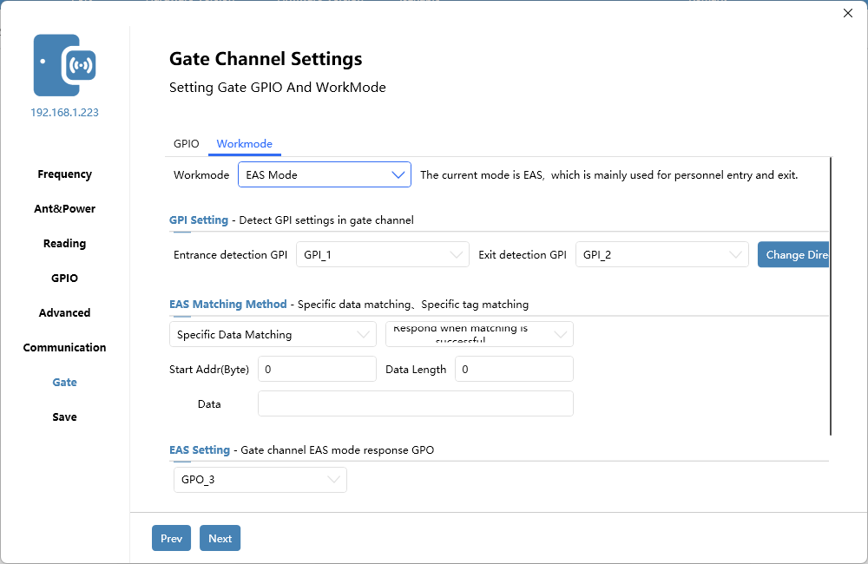

2.5）Change Password
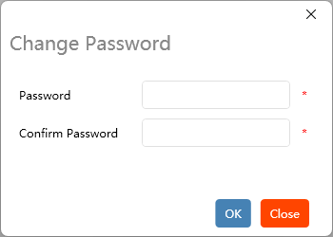
- Double-click the [Change Password] option to open the interface above, where we can change the login password

2.6）Database Setting
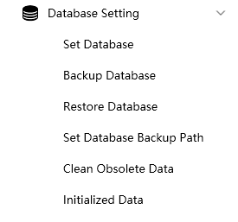
The database settings integrate some quick operations on the database, which are:
- Set database: Set the current database type to SQLite or SQLServer
- Database backup: Back up the current database
- Restore database: Select the backed-up database and restore the data back to the backed-up data.
- Set the database backup path: Database backup data
Obsolete data removal：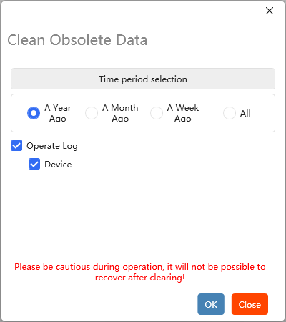
- Data initialization：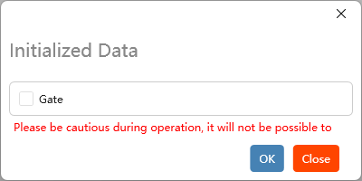

2.7）Upload Template
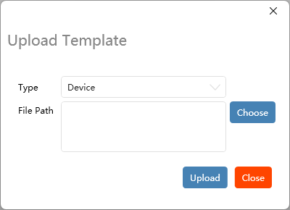
- Double-click the [Template Upload] option to open the interface above, which is used to upload the template downloaded by [Download and Import Template]. Generally, you can use our own template. If you have special needs, you can contact us for custom development.

2.8）Server Configuration
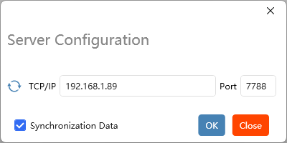
Server configuration is used to set the remote server of the current device to the current IP address with one click

